CO1-ASSSESSMENT TOOL-OUTPUT PREDICITION
COURSE NAME: DATA STRUCTURE NAME: CH. SURYA TEJA
COURSE CODE: CSA0307 REG NO: 192525259
DATE: 24-07-2026
QUESTION: 1 – REVERSE A LIST
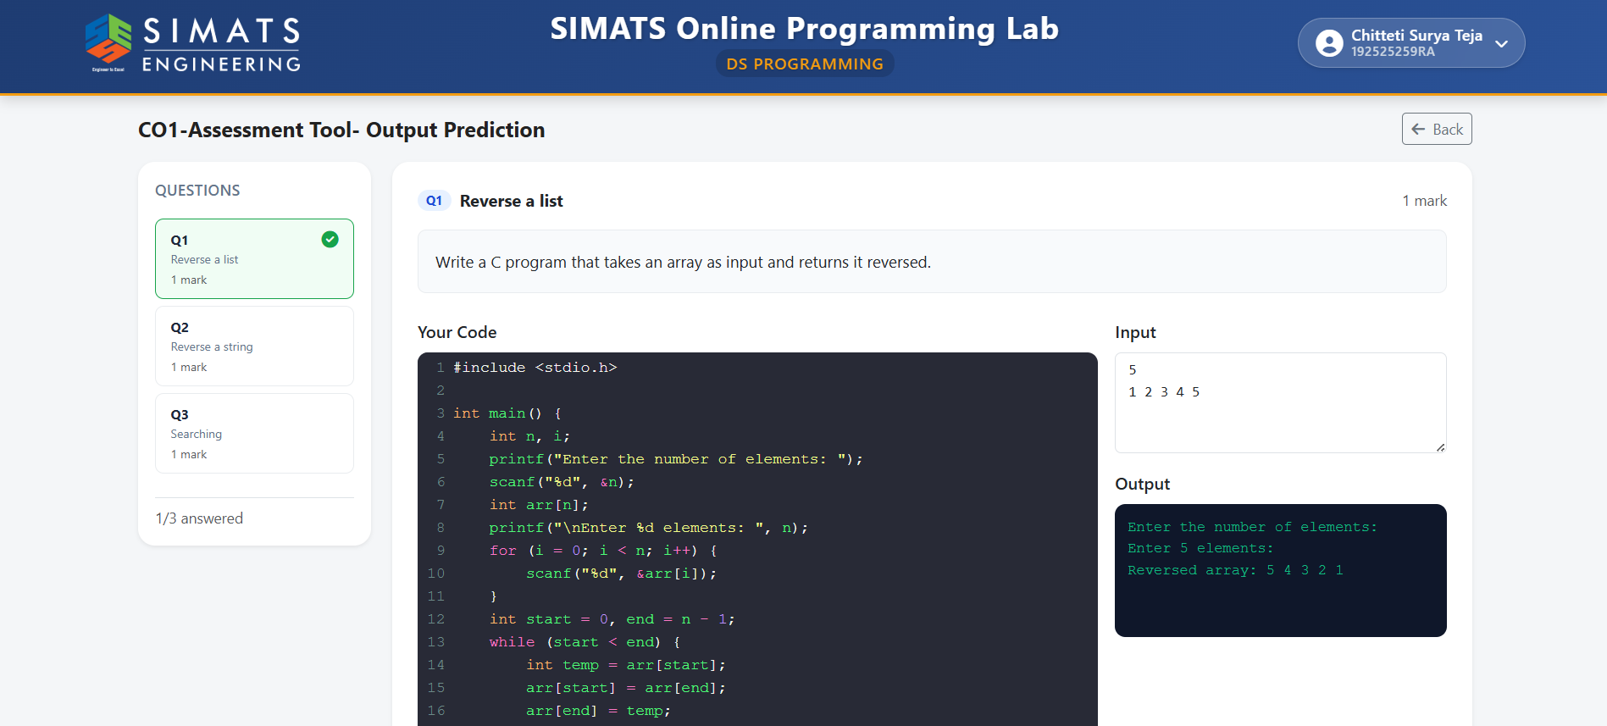

QUESTION: 2 – REVERSE A STRING
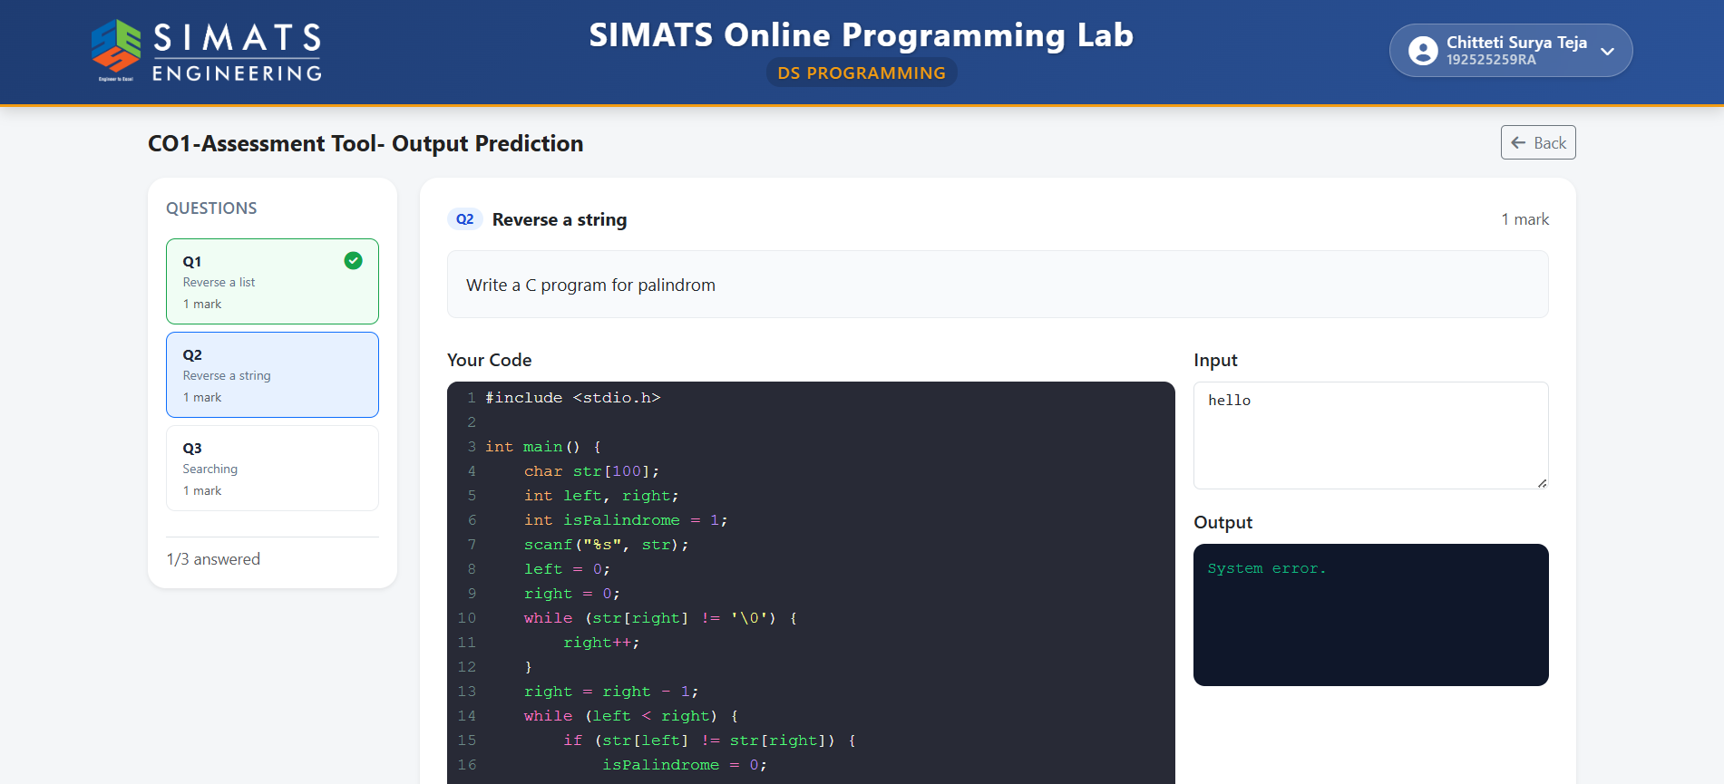

QUESTION: 3 - SEARCHING
